**THE DEVELOPMENT AND IMPLEMENTATION OF A LEARNING MANAGEMENT SYSTEM, DUX.**

**SOFTWARE ENGINEERING FACULTY**

**OF**

**NEAR EAST UNIVERSITY**

**BY**

**List of Abbreviations**

(AI)- Artificial intelligence

(LMS)-Learning Management Systems

**ABSTRACT**

Use Artificial intelligence in education is A smart learning system that provides the best way of teaching and studying worldwide, and makes attention to all schools and universities, It covers all areas of education, simplifies education, and makes it easier. Here are some ways AI can help in education it can help students understand course material even if it is difficult for them Artificial intelligence (AI) can offer ways to simplify class notes and make them understandable depending on what learners ask, it can analyze and track learners progress and show them where or which course they can add more support and effort. it can help educators create course material more easily than create themself, it can interact more with educator and learners together in school or at home. It can assist all teachers and students and give them better options depending on the questions they ask.

**Keywords:** Artificial intelligence in education, Use Artificial intelligence in learning, Smart Online Learning Management System, Smart educational tools and learning management systems

**INTRODUCTION**

Education is important to everyone in the whole world around 90% population has completed primary education and 66% have attained secondary education. Several percentages continue in high school and the university. percentages have decreased due to many reasons [1] lack of material 31% of students from primary school and the upper school cannot be reached due to lack of police support digital and broadcasting. [2] online reading has become popular, especially after the COVID-19 Pandemic it’s obvious that over 1.9 billion learners were affected. This time all schools moved to online teaching and studying and faced many challenges because it happened fast without anyone's attention, which makes Artificial intelligence more important to make education more simple and suitable for everyone.   
[3] Artificial intelligence (AI) is a branch of computer science that focuses and building technology that can automate reading and adapt human behaviors more focuses on teaching systems that can control its self and think without waiting for human touch or interaction,

We are living in a world where technology is everything, artificial intelligence (AI), is a major in daily life it is

and deep learning has taken place in every inch part of every life, especially in education, It has The quality of all learning types, such as distance, online, and face-to-face has been improved.

several challenges need to be addressed. Firstly, students face difficulties in understanding the course material depending on the complexity of the topic.

Additionally, keeping track of their progress and ensuring that they complete their assignments and homework on time poses a significant challenge. On the other hand, teachers have to devote a considerable amount of time to creating teaching materials such as videos and textbooks.

They also struggle with managing exams, scheduling timetables, and creating exam papers.

[4]Artificial intelligence has generally overcome all challenges in education "Artificial Intelligence (AI) has the potential to simplify education and adapt learning styles. It can analyze students' performance and provide personalized recommendations to enhance their learning experience."

Moreover, it can automate education and take more tasks such as grading and admission and give time for an educator to focus on teaching and interact with students, it provides a tutorial system and interacts more with students in school and at home as well, it can provide education and attract students to study and practice to their course in group or on to one,

By motivating how artificial intelligence art this paper drives further examination of how is important and has given a big contribution to education

**Smart Online Learning using Artificial Intelligence Learning Management** System

**Web Application**

**MACHINE LEARNING**

**PHP**

**MYSQL**

**JAVASCRIPT  
CSS  
HTML**

**Generative Algorithm**

*Figure 1*

**LITERATURE REVIEW**

One of the systems that help students to learn and maintain their independence, zeal, and drive, the author describes the usage of Learning Management Systems (LMS) to provide virtual classroom settings that support the learning process to engage learning environment created by the presence of an instructor, by combining the use of LMS technology tools and rules from the approved curriculum with active learning to organize online activities, lead and model discussions, and also achieve learning objectives, provide students options, and help them solve problems by helping them make decisions.

[5] particular research aims to show the Initial and Experimental results regarding textual documents from learning repositories and online discussion forums. The author says It is capable of both instructing students on the learning process and providing automated feedback on online learning delivery to online learning management. Their study's dataset was sourced from the Bina Nusantara Online Learning repository. An intriguing finding of the study was that there is a substantial difference in the cognitive domain Taxonomy level of questions asked in discussion forums and the corresponding level of learning outcomes. ANOVA was used to confirm these results, yielding a P-value of 0.86 and < 0.05. The Naive Bayes classifier's accuracy.

[6]The author intended to insights on how students might support one another in reaching learning objectives and developing self-control. When taking classes online. The feedback shows how educators are not physical which learners accomplish, showing that automated feedback improves students' performance in tasks by a total of 65.07%;   
According to 46.03% of the research, there is no proof that automatic feedback reduces the workload of instructors; There is no proof that manual feedback is more effective than automatic feedback, according to 82.53% of the research.

[7] The paper shows many ethical challenges in education and how artificial intelligence can address them. A paper Introduces applications of AI in educational settings and highlights the benefits of AI systems to support students' learning processes. Describes ethical challenges and dilemmas of using AI in education. Addresses the teaching and understanding of AI by offering suggested instructional resources from two providers. Briefly define AI through the concepts of machine learning and algorithms.

**METHODOLOGY**

The methods and purpose used to achieve the Smart Online Learning Management System by utilizing web-based integrated into the university platform AI technology lid in this area, and show how AI will affect education morally An AI can look at multiple facets of education such as administration, instruction, and learning and to evaluate how AI impacted the whole area of education.

As seen in Figure 1, this study incorporates and exhibits more information and steps involved in each phase of the experiment. For example, all the program uses to create application. The language takes to handle all input and output of user.

**Materials and Method**

The design method of the project has divided into different categories such as Web-application part, Database part, and Generative Algorithm   
below is list of programs use to complete a project.  
**HTML-** is the standard markup language.  
in this project HTML use for to create web

**PHP-**is Server-side scripting language in this project php use for interact with database and frontend

**MYSQL -**is a relational database management system is use in project use to store data and save it

**JAVASCRIPT-**is program language use to create and modify webpage **CSS-**is use to decorate webpage

The system I’m trying do to will have couple features such as the ones below.

**Creating Presentations from E-Books**

This is a feature that will enable a teacher to upload learning content such as a PDF and the system will be able to extract content from it and create a presentation. The presentation will be able to be spoken out loud so that students can listen to it as a lecture, as if he or she was in class. Any images that are in the original content will be kept as well so that the examples aren’t lost. In addition to that, the teacher will be able to edit any extracted content, add new information as well as have it regenerated differently with the same context. This feature will speed up the generation of presentations, so that the teacher can focus on other pressing things.

**Asking Questions and Get Answers in multiple languages.**

Users can ask requests in many languages and receive replies in the same language you asked while using this function. These characteristics' AI often uses sophisticated models to comprehend the query, find pertinent data, and produce a well-reasoned response in the desired language.

**Here How this feature work**

* **User Question**: The user fills out the space provided with their query.   
  **AI Processing**: The AI evaluates the query, finds pertinent data, and produces a response.   
  **Answer Generation:** In the same language as the inquiry, the AI generates an answer.

**Responding with voice in multiple languages**

An AI system can normally respond in several languages using synthetic speech thanks to the "Responding with voice in multiple languages" capability. Language translation services and text-to-speech (TTS) technologies are frequently used in conjunction to accomplish this.

An example of how such a feature could function is as follows:

* **User Interaction**: The user speaks or types in their preferred language to communicate with the system.
* **AI Processing:** After analysing user input, the AI system produces a response in the same tongue.
* **Translation and Synthesis:** Next, the response is converted from text to speech using TTS library technology and translated into the desired language
* **Voice Output:** The user hears the synthesized speech played back to them, answering in their native tongue.

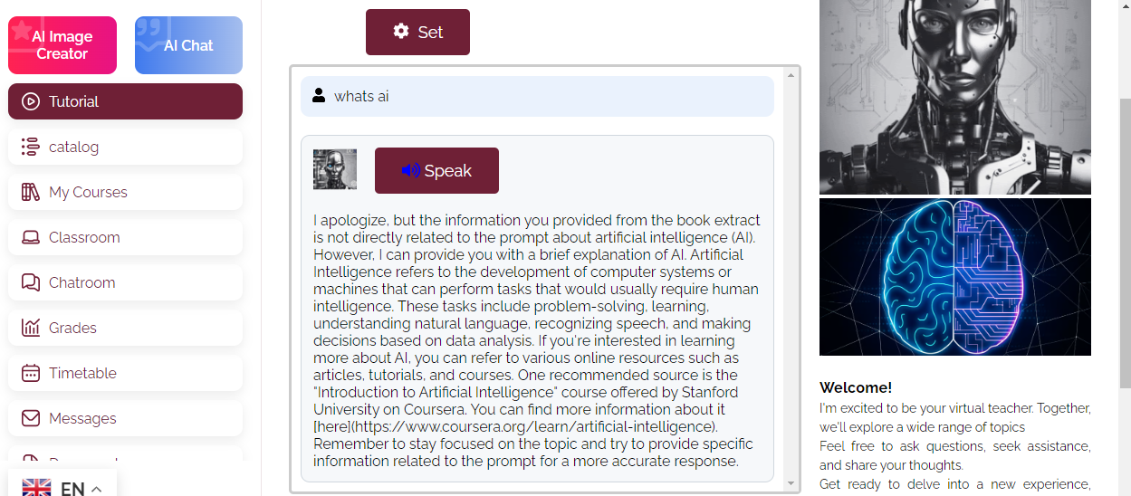

*FIGURE 2 USER ASKING QUESTION AI RESPOND*

**Chatting room for students**

Generally speaking, the term "Chatting room for students" describes a virtual area where students can communicate with one another in real time. This can be a useful tool for encouraging group projects, conversations, and peer education.   
  
An example of how such a feature could function is as follows:

* **Access:** Using the platform students can access the chat room.
* **Interaction:** Students can post messages, ask questions, exchange ideas, and reply to one another in the chat room.
* **Moderation:** The chat room may be monitored in order to maintain a polite and safe atmosphere. This can entail guidelines for proper conduct as well as the possibility of a moderator to enforce these guidelines.
* **Collaboration:** Study groups, group projects, and general academic conversations can all be conducted in the chat room. It could be useful.

**GPA prediction**

A tool that predicts a student's future Grade Point Average (GPA) using a variety of parameters is commonly referred to as the "GPA prediction" function. These variables may include prior academic success, the challenge of the course, study techniques, and more. These inputs are used by the tool to forecast the GPA.  
An example of how such a feature could function is as follows:

* **Data Collection:** The tool gathers pertinent data, including course load, prior grades, and other significant details.
* **Algorithm Processing:** The tool analyses the data and projects the student's future GPA using an algorithm, frequently based on statistical or machine learning techniques.
* **Prediction Output:** A predicted GPA is produced by the tool, frequently along with a confidence interval or a range of potential results.

uses AI-driven algorithms to analyze learning patterns, pace, and strengths to tailor instruction for each student. It can quickly identify areas where students are underperforming and provide the necessary assistance by analyzing performance information in real-time1. This might incorporate GPA forecasting.

**Messaging between teachers and students**

A communication tool that enables direct interaction between teachers and students within a digital platform is usually referred to as the "Messaging between teachers and students" feature. This can be a useful tool for answering questions, talking about homework, and giving feedback.   
  
An example of how such a feature could function is as follows:

* **Access:** Via the platform educators and students can use the messaging feature.
* **Communication:** Messages can be sent and received between teachers and students. This can apply to text, links, attachments, and more.
* **Notifications:** To guarantee prompt communication, users may get alerts whenever a new message is received.
* **Privacy:** The teacher and student's messages are usually confidential, providing a secure and safe communication environment.

**Scheduling classes**

Generally speaking, the "Scheduling classes" function refers to a tool that helps administrators and teachers schedule and arrange classes for a specific time. This can involve allocating instructors and students to each class, as well as determining the day, time, and location of each one.  
  
An example of how such a feature could function is as follows:

* **Access:** Via the platform educators and administrators can use the scheduling tool.
* **Planning:** Each class's date, time, and place can be chosen by the user. Teachers and students can be assigned to each class as well.
* **Notifications:** Teachers and students who need to know about their class schedule can receive notifications once the schedule is finalized.

**Quiz Generation and Marking**

Generally speaking, the "Quiz Generation and Marking" function refers to a program that can generate quizzes automatically based on predetermined standards and then grade them after they are finished. Teachers may find this to be a useful tool since it can help them save time and give pupils feedback right away.   
  
An example of how such a feature could function is as follows:

* Quiz Generation: The program generates quiz questions based on AI algorithms or pre-established parameters. These might be predicated on particular subjects, degrees of difficulty, or question kinds (multiple choice, short answer, etc.).
* **Taking the Quiz:** Students use the platform to complete the quiz. When they're ready, they can respond at their own speed and submit.
* **Quiz Marking:** The quiz is automatically graded by the tool after it is submitted. It can deliver results and feedback right away.

**Exam Generation and Automatic Marking**

Generally speaking, the "Exam Generation and Automatic Marking" function refers to a program that can generate tests automatically based on predetermined standards and then grade them after they are finished. Teachers may find this to be a useful tool since it can help them save time and give pupils feedback right away.   
  
An example of how such a feature could function is as follows:

* **Exam Generation:** The tool creates exam questions based on preset standards or artificial intelligence algorithms. These might be predicated on particular subjects, degrees of difficulty, or question kinds (multiple choice, short answer, etc.).
* **Examining:** Students use the platform to take the exam. When they're ready, they can respond at their own speed and submit.   
  Automatic Marking: The exam is automatically graded by the tool once it has been submitted. Students can comprehend their performance and areas for improvement with the help of the instant scores and feedback it may offer.
* **Automatic Marking:** The exam is automatically graded by the tool once it has been submitted. Students can comprehend their performance and areas for improvement with the help of the instant scores and feedback it may offer.

**Automatic Presentation Creation from Coursebooks**

In general, the term "Automatic Presentation Creation from Coursebooks" refers to a feature that allows teachers and students to benefit from time-saving tools that also improve comprehension through the use of visual aids. The following is an outline of how such a feature might operate:

**Content Analysis:** The tool examines the coursebook's content to identify key points, topics, and sections;

**Slide Generation:** The tool utilizes this information to create a series of slides, each of which may cover a different coursebook topic or section.

**Enhancement:** To improve comprehension, the tool may additionally include pictures, charts, or other visual aids on the slides.   
**Customization:** Users may be able to add their own notes, alter the layout, and make other changes to the generated presentation.

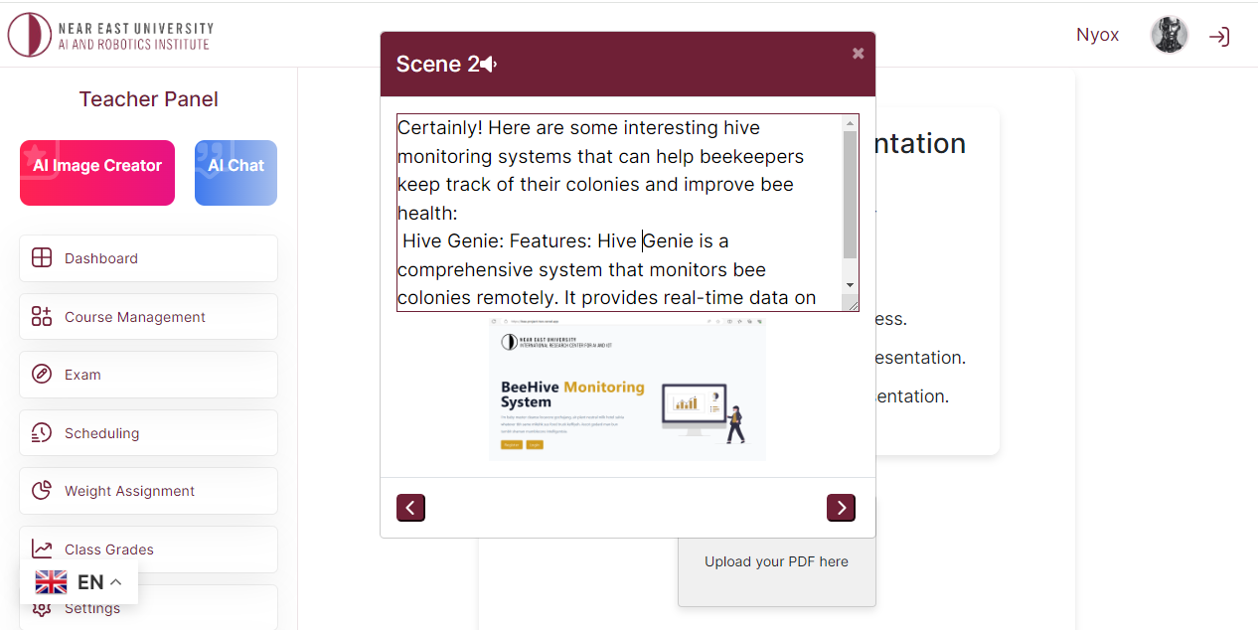

*FIGURE 3 CREATE PRESENTATION*

**RESULT**

The system that is going to be built is supposed to improve the learning experience of a students and teaching experience of the teacher in a way that is superior to current methods that are being used in the current era. When in class, the student needs to feel like the system knows him or her in a personal way and can adjust to his learning style and pace.

The system will be able to assess a student at the rate that they are learning at, be able to give him or her quizzes and exams, save the results and show learning progress over time. With the prediction feature, we can give the student a guess on how much they would score on the next quiz and a possible result for their exam based on their past assessments. With these metrics we will be able to gauge where that student falls short in learning and help him or her in filling in learning gaps.

We will be able to measure the efficiency and accuracy of the system by asking the students at the end of the semester or by comparing the predicted grades that were given by the system with the actual ones the student scored. This will in turn be fed back into the system to improve the accuracy.

In short the metrics that we are looking for in the system are:

* Efficiency in teaching
* Accuracy in answering questions
* Accuracy in understanding nuanced questions and learning content
* Quiz and Exam Generation Quality
* Quiz and Exam results prediction
* GPA prediction

**What we are trying to achieve** is a wholesome system that takes a student from point A or not knowing a subject, to point B, where they know the subject, by teaching them in a way that they would understand. The benefits of this system are that it is online, pacing the student in a way that they can handle. The automation of the system allows it to be available 24/7 such that it can be used whenever required without the need of a physical teacher.

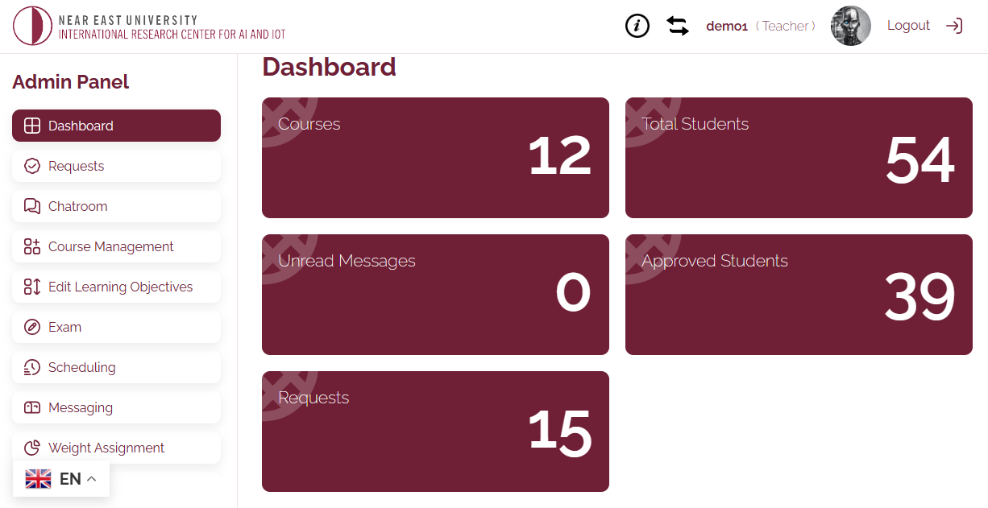

FIGURE 3 TEACHER PANNEL

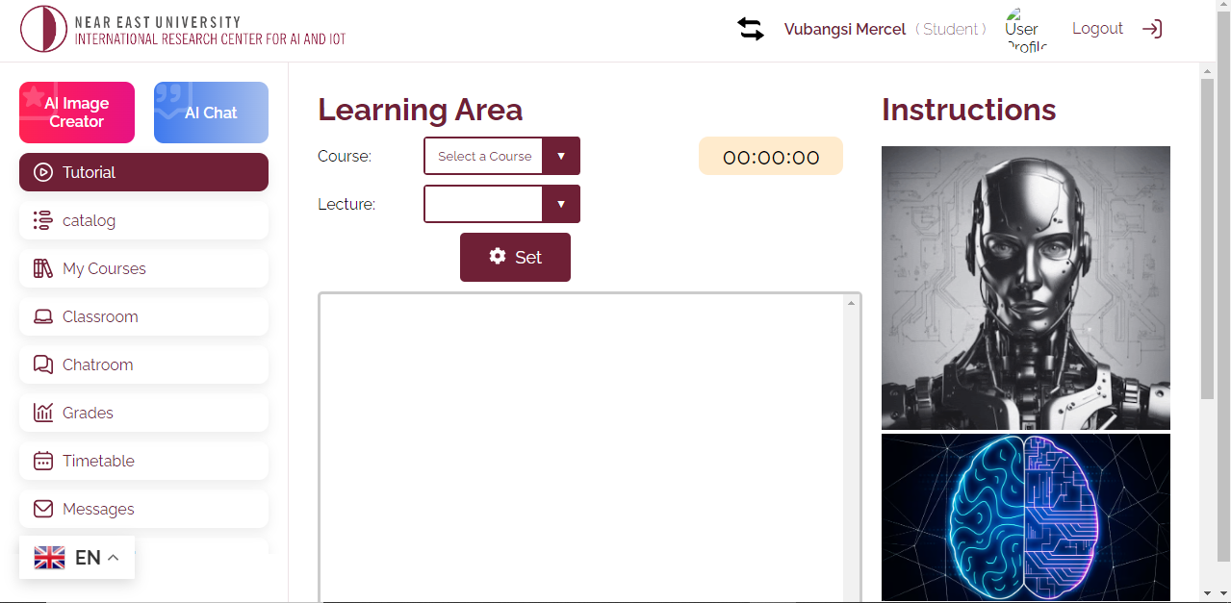

*FIGURE 5 STUDENT PANNEL*

**conclusion**   
In conclusion, the development of the AI-powered education learning system learning management SYSTEM is a significant step in revolutionizing the traditional university-level learning experience. System offers personalized, adaptable, and engaging learning experiences that are tailored to the particular needs and preferences of each learner by integrating cutting-edge technologies like ChatGPT, PHP, JavaScript, CSS, and MySQL. With its lively conversational exchanges, user-friendly interface, and adaptable training approaches, the learning management system seeks to enhance greater engagement, comprehension, and retention of educational content across a broad spectrum of subjects. System has the power to impact education in the future by providing students with the instruments and materials need to thrive in an ever-evolving world.

**references**

[1] Andreas Schleicher, *Shortage of material resources in schools and reading performance*, vol. 5. 2018.

[2] M. Sabine, F. Julian, and S. Rolf, *The impact of the COVID-19 pandemic on education: international evidence from the Responses to Educational Disruption Survey (REDS)*. 2022.

[3] B. J. Copeland, “Copeland, B.J. (2024). "Artificial intelligence (AI) | Definition, Examples, Types, Applications, Companies, & Facts | Britannica”.

[4] V. M. Bradley, “Learning Management System (LMS) Use with Online Instruction,” *International Journal of Technology in Education*, vol. 4, no. 1, 2020, doi: 10.46328/ijte.36.

[5] X. Chen, D. Zou, H. Xie, G. Cheng, and C. Liu, “International Forum of Educational Technology & Society Two Decades of Artificial Intelligence in Education,” *Technology & Society*, vol. 25, no. 1, pp. 28–47, 2022, doi: 10.2307/48647028.

[6] A. P. Cavalcanti *et al.*, “Automatic feedback in online learning environments: A systematic literature review,” *Computers and Education: Artificial Intelligence*, vol. 2. Elsevier B.V., Jan. 01, 2021. doi: 10.1016/j.caeai.2021.100027.

[7] S. Akgun and C. Greenhow, “Artificial intelligence in education: Addressing ethical challenges in K-12 settings,” *AI and Ethics*, vol. 2, no. 3, pp. 431–440, Aug. 2022, doi: 10.1007/s43681-021-00096-7.